**PRACTICAL-10-YASH SHAH**

**AIM-Perform Automation Testing on the moduls that you have developed for mini project. Apply test cases that you have carried out in previous practical**

**TESTING ADMIN MODULE OF LIBRARY MANAGEMENT SYSTEM**

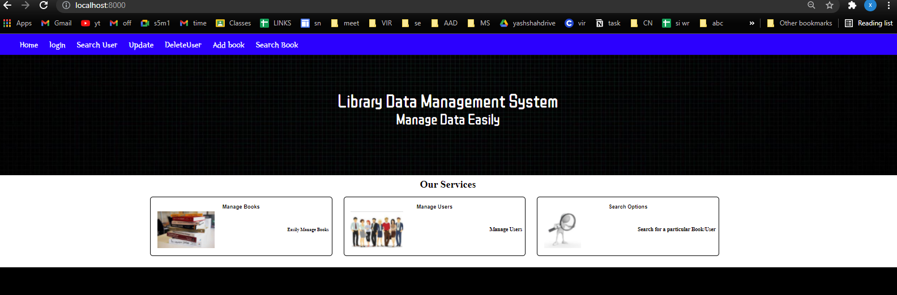

**1)Testing Login Module**

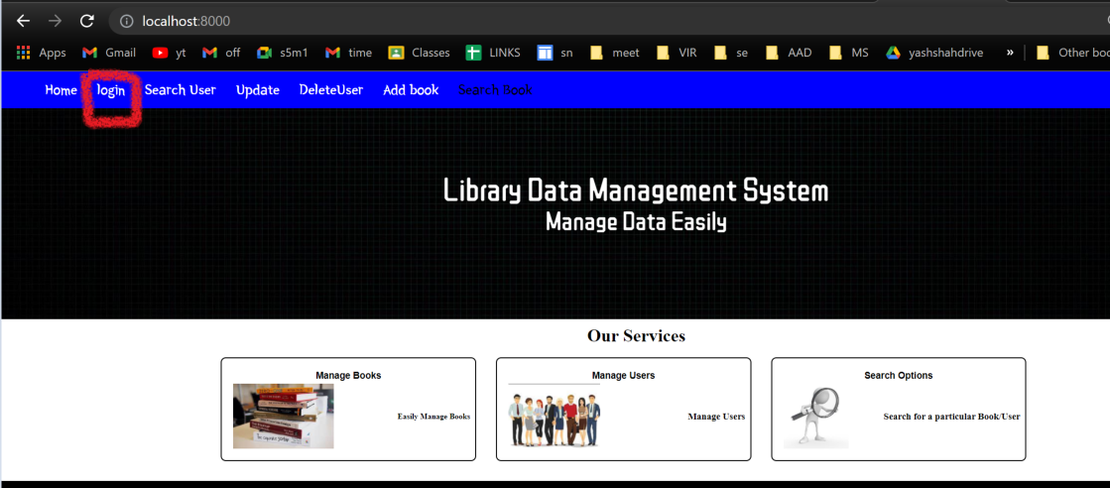

**CODE**

from selenium import webdriver

from selenium.webdriver.support.ui import WebDriverWait

from webdriver_manager.chrome import ChromeDriverManager

from selenium.webdriver.chrome.options import Options

import time

driver = webdriver.Chrome(ChromeDriverManager().install())

driver.get("http://localhost:8000/login")

driver.maximize_window()

a=driver.find_element_by_name("uname")

a.send_keys("yash")

b=driver.find_element_by_name("psw")

b.send_keys("yash@123")

c=driver.find_element_by_xpath("//body/form[@action='/login']//button[@type='submit']")

c.click()

**OUTPUT**

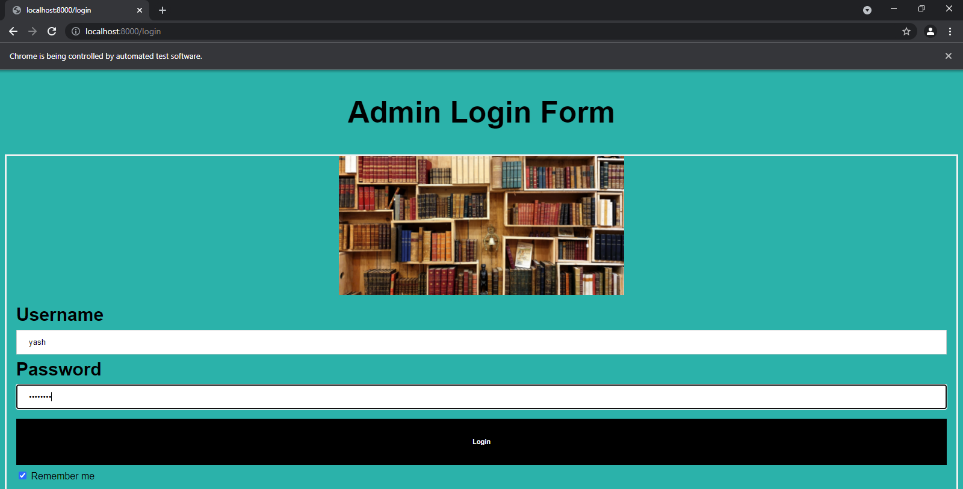

**AFTER LOGIN SUCCESFULLY REDIRECTED TO ADMIN PANEL**

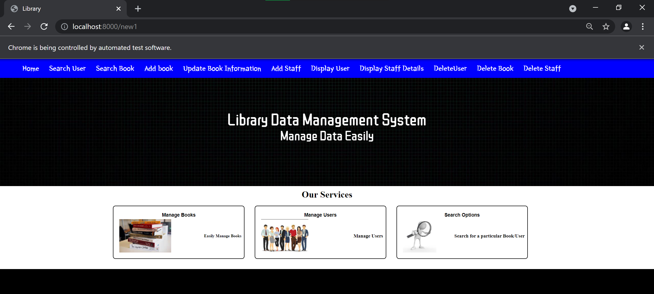

**2)Testing Add Book Feature**

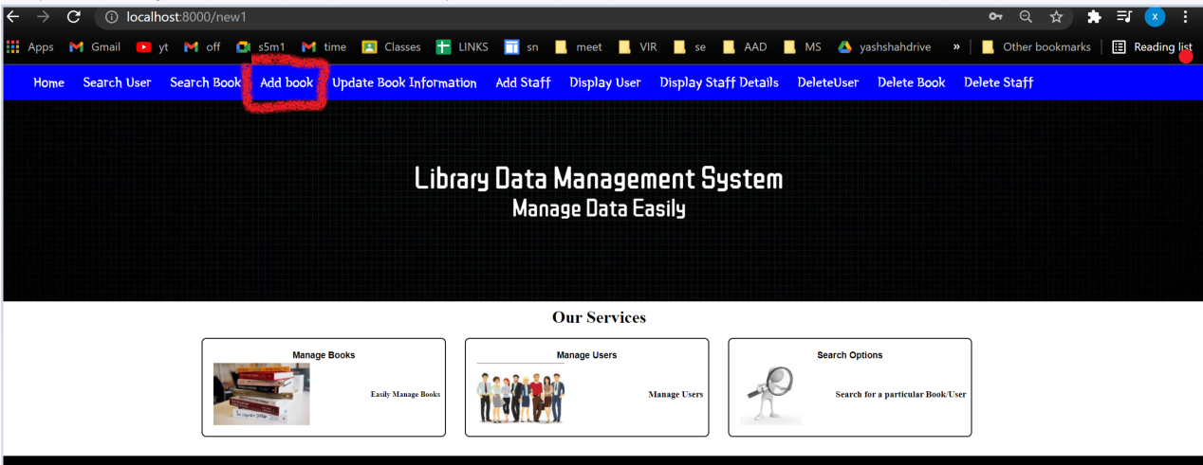

**CODE**

from selenium import webdriver

from selenium.webdriver.support.ui import WebDriverWait

from webdriver_manager.chrome import ChromeDriverManager

from selenium.webdriver.chrome.options import Options

import time

driver = webdriver.Chrome(ChromeDriverManager().install())

driver.get("http://localhost:8000/new1")

driver.maximize_window()

time.sleep(3)

addbook=driver.find_element_by_xpath("//nav[@id='navbar']/ul//a[@href='/addbook']")

addbook.click()

time.sleep(2)

bookname=driver.find_element_by_name("bookname")

bookname.send_keys("abc")

author=driver.find_element_by_name("author")

author.send_keys("xyz")

price=driver.find_element_by_name("price")

price.send_keys("323443")

time.sleep(3)

submit=driver.find_element_by_xpath("//body/form[@action='/addbook']/div[@class='container']//h5[.='ADD BOOK']")

submit.click()

driver.find_element_by_class_name("")

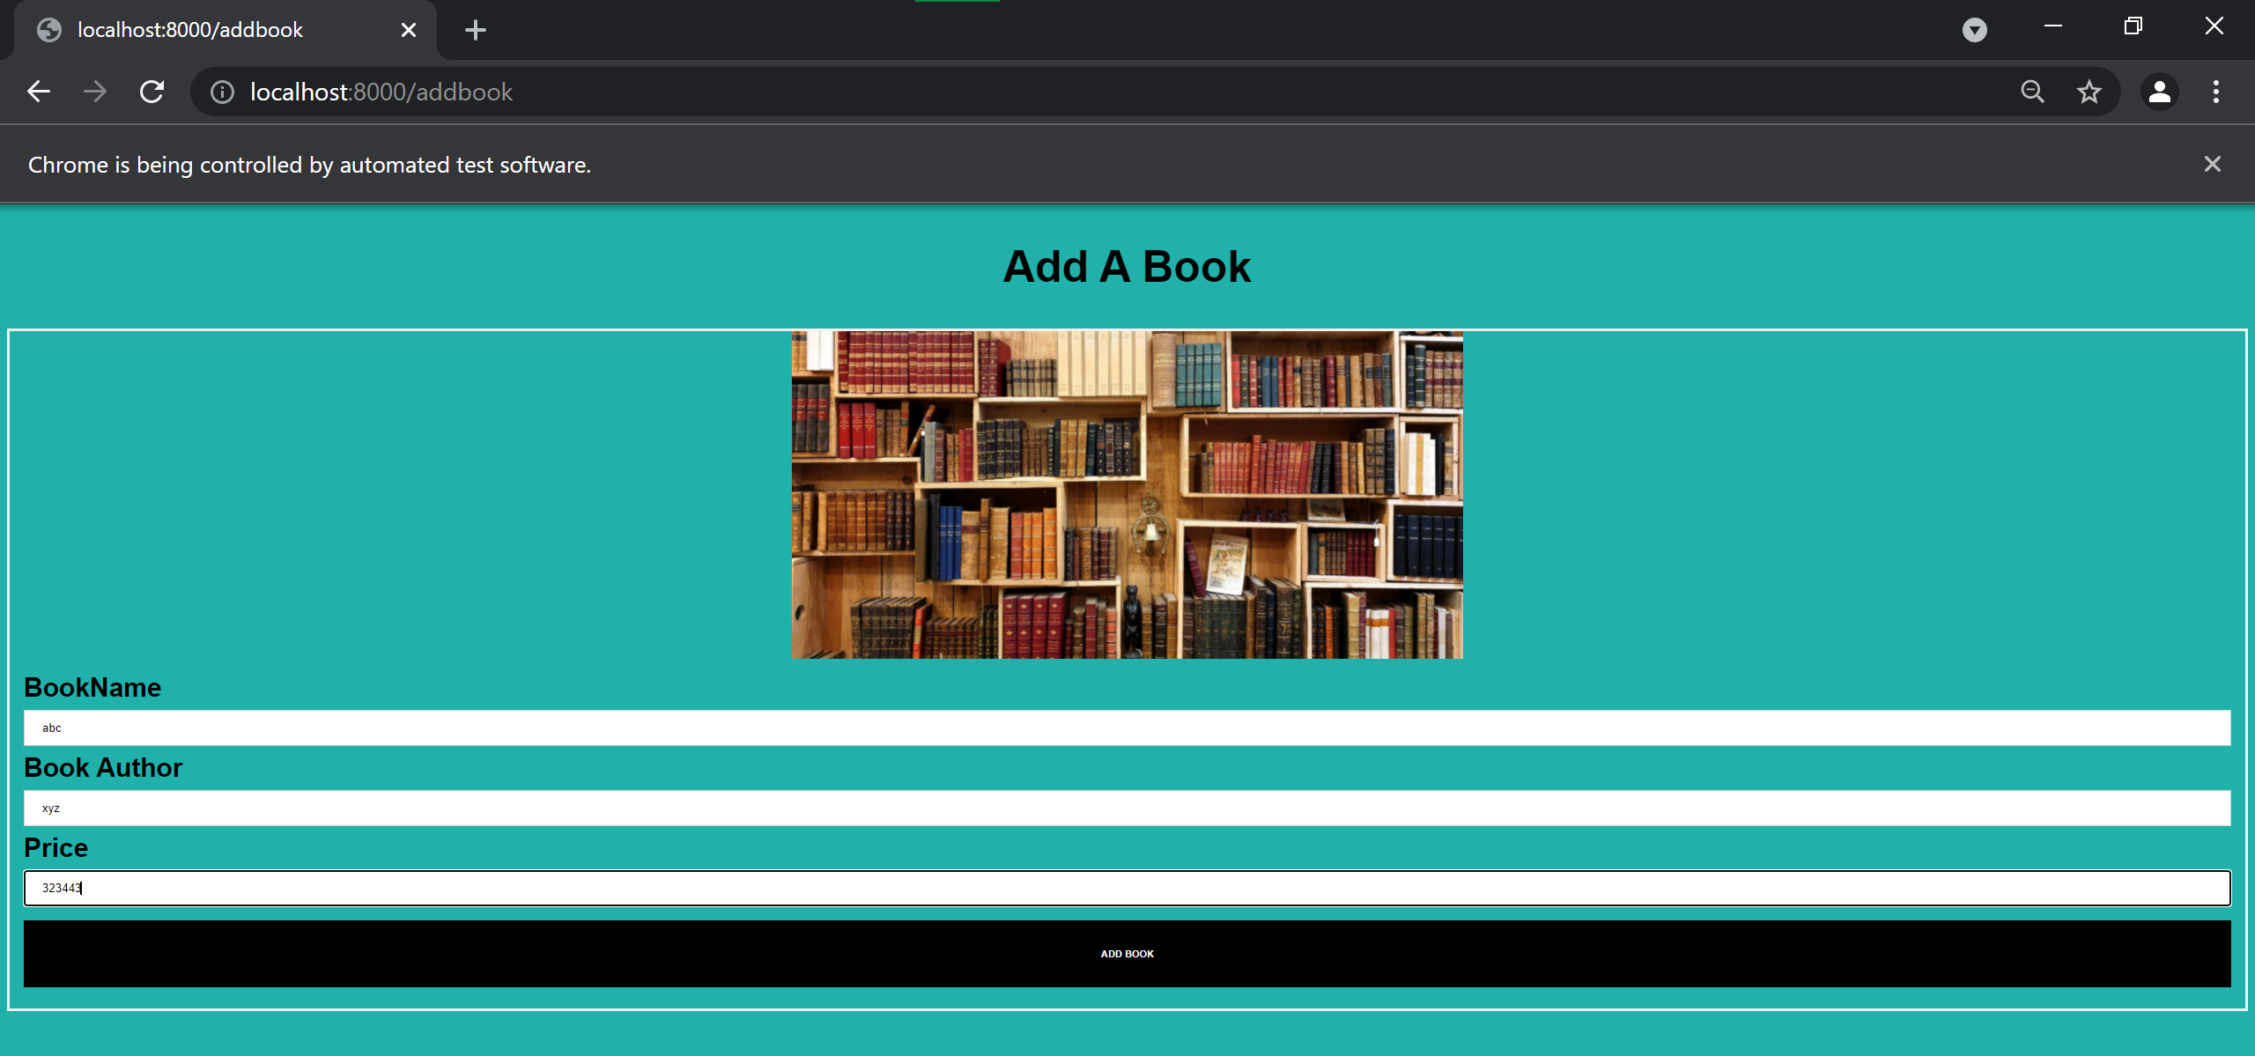

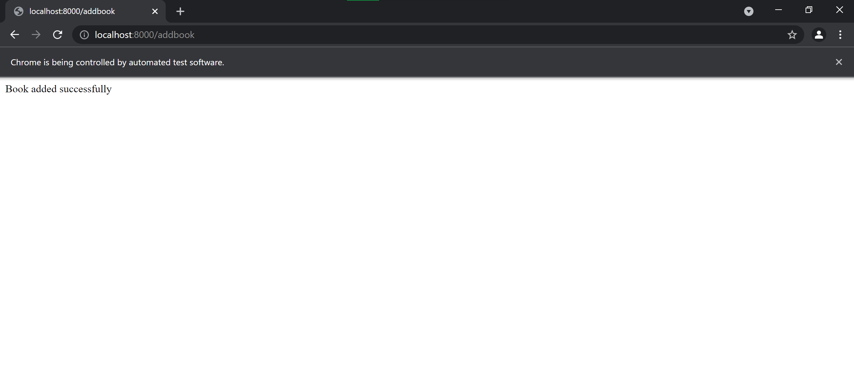

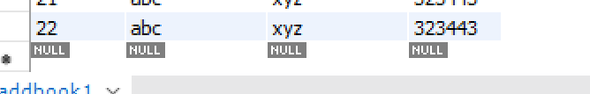

**3)Update book Information Test**

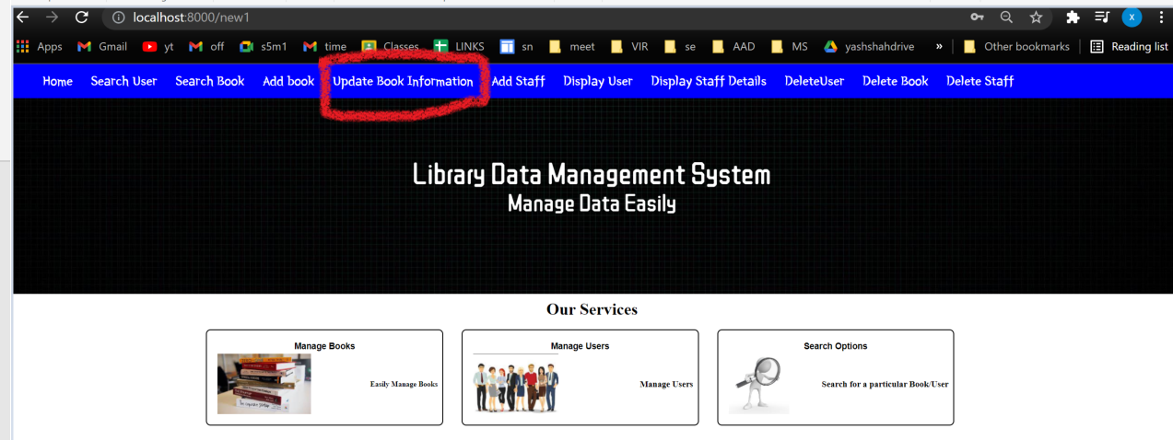

**CODE**

from selenium import webdriver

from selenium.webdriver.support.ui import WebDriverWait

from webdriver_manager.chrome import ChromeDriverManager

from selenium.webdriver.chrome.options import Options

import time

driver = webdriver.Chrome(ChromeDriverManager().install())

driver.get("http://localhost:8000/new1")

driver.maximize_window()

time.sleep(3)

updatebook=driver.find_element_by_xpath("//nav[@id='navbar']/ul//a[@href='/pay']")

updatebook.click()

time.sleep(2)

bid=driver.find_element_by_name("book_id")

bid.send_keys("4")

bookname=driver.find_element_by_name("bookname")

bookname.send_keys("pritam")

author=driver.find_element_by_name("author")

author.send_keys("xyz")

price=driver.find_element_by_name("price")

price.send_keys("12343")

submit=driver.find_element_by_xpath("//body/form[@action='/pay']//button[@type='submit']")

submit.click()

**Before Update**

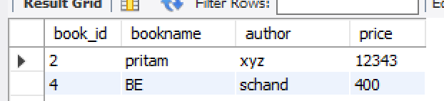

**OUTPUT**

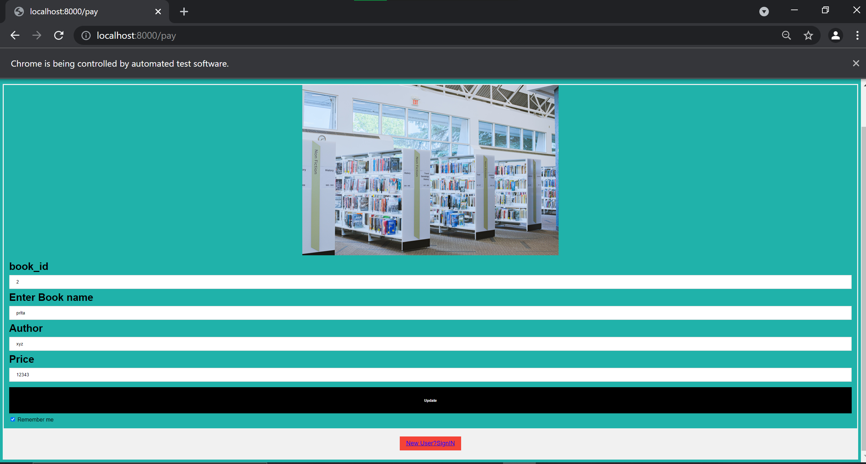

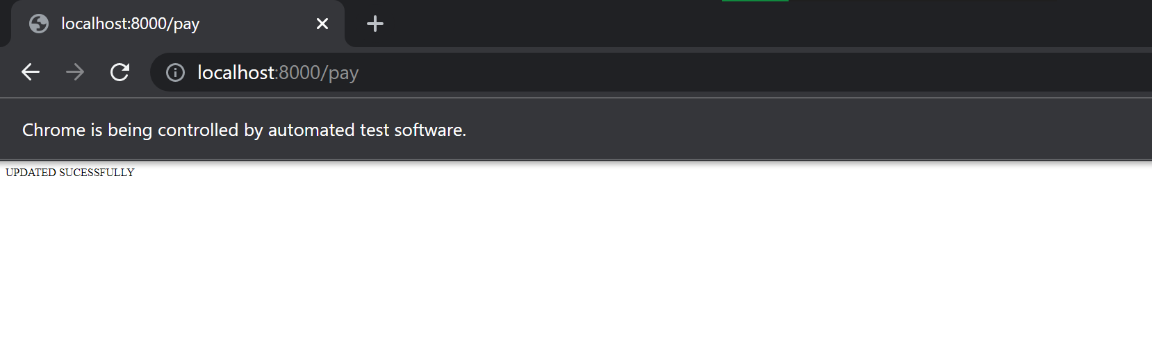

**4)Display User Functionality Test**

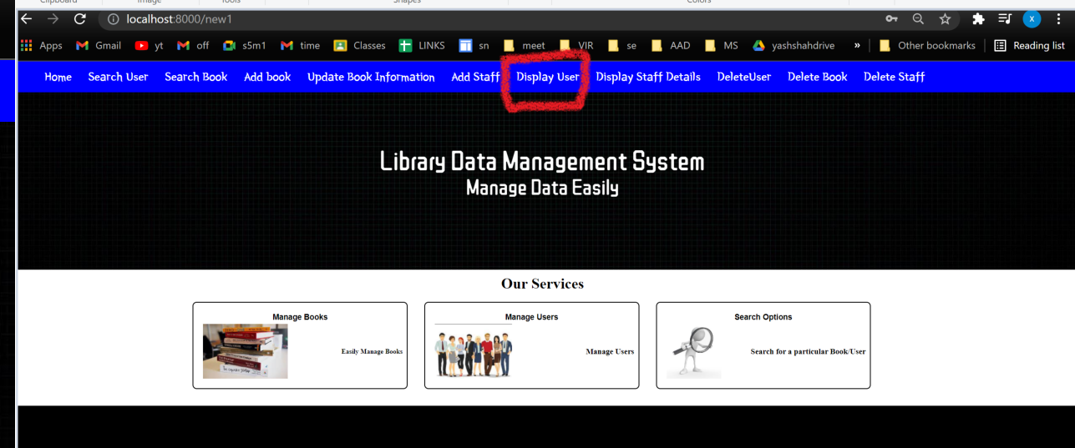

**CODE-**

from selenium import webdriver

from selenium.webdriver.support.ui import WebDriverWait

from webdriver_manager.chrome import ChromeDriverManager

from selenium.webdriver.chrome.options import Options

import time

driver = webdriver.Chrome(ChromeDriverManager().install())

driver.get("http://localhost:8000/new1")

driver.maximize_window()

time.sleep(3)

ds=driver.find_element_by_xpath("//nav[@id='navbar']/ul//a[@href='/disp']")

ds.click()

**OUTPUT**

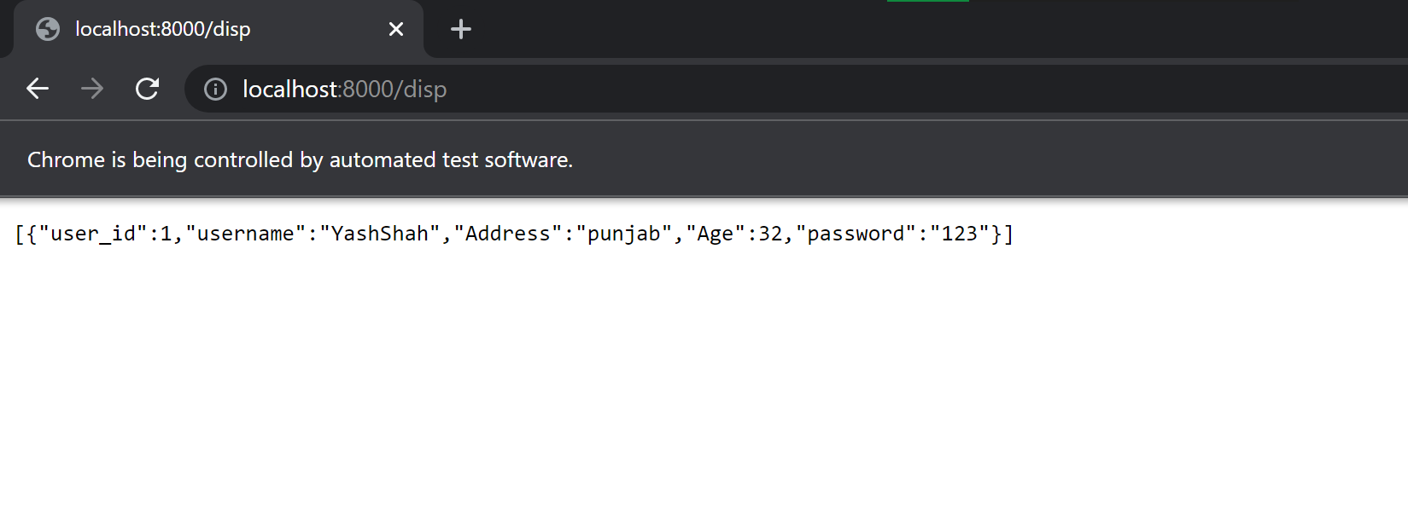

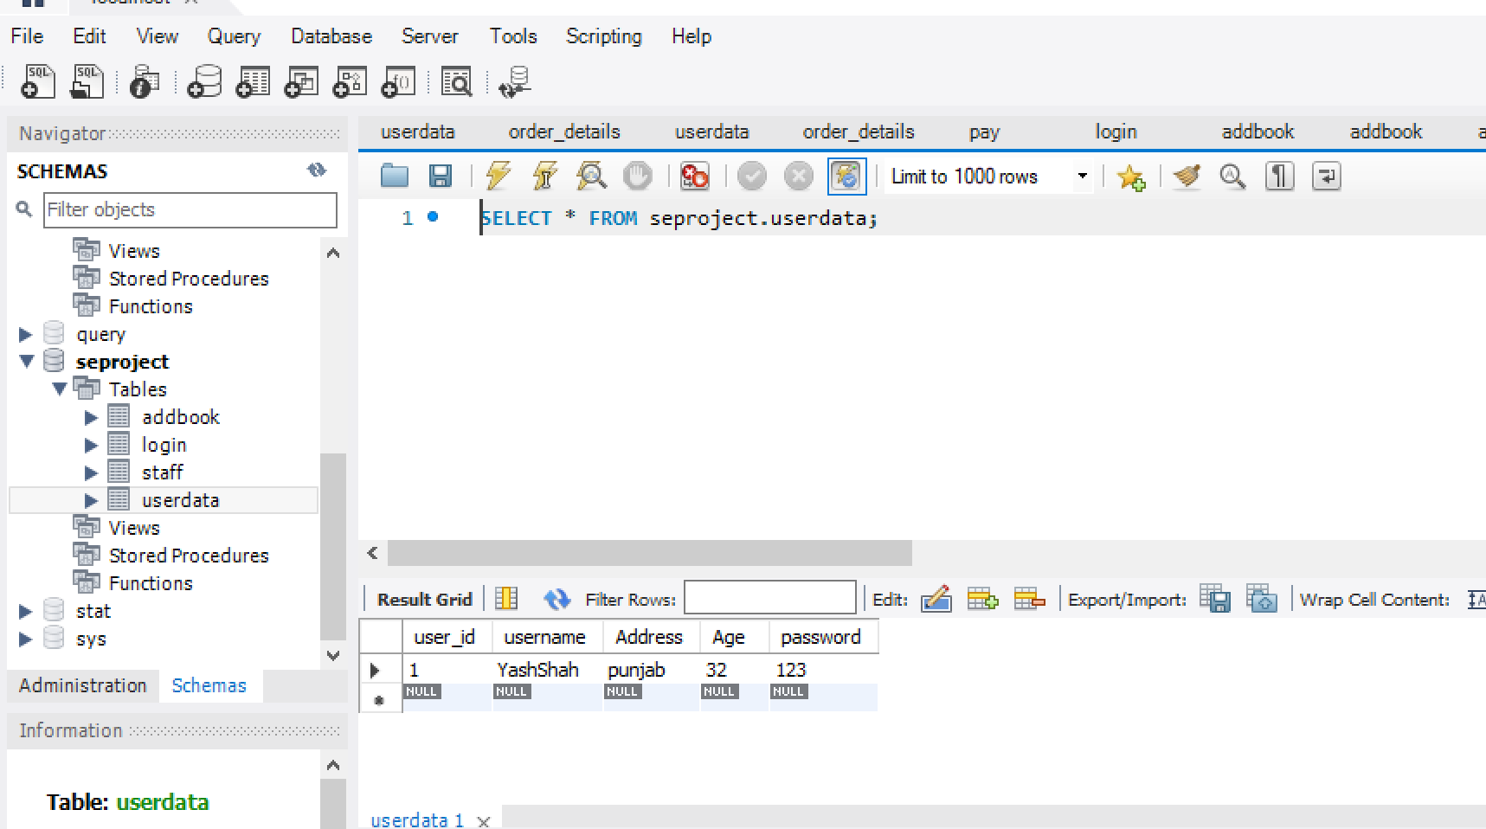

**5)Display Staff Details Test**

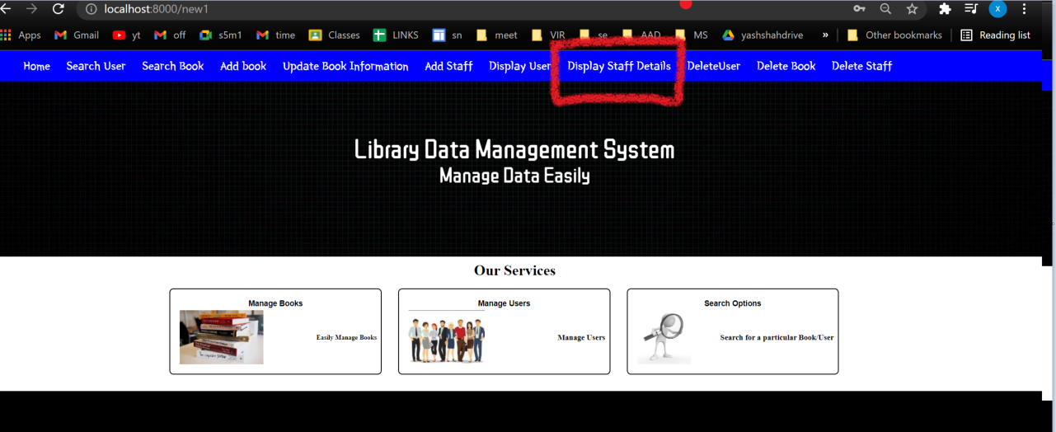

**CODE-**

from selenium import webdriver

from selenium.webdriver.support.ui import WebDriverWait

from webdriver_manager.chrome import ChromeDriverManager

from selenium.webdriver.chrome.options import Options

import time

driver = webdriver.Chrome(ChromeDriverManager().install())

driver.get("http://localhost:8000/new1")

driver.maximize_window()

time.sleep(3)

ds=driver.find_element_by_xpath("//nav[@id='navbar']/ul//a[@href='/dispstaff']")

ds.click()

**OUTPUT**

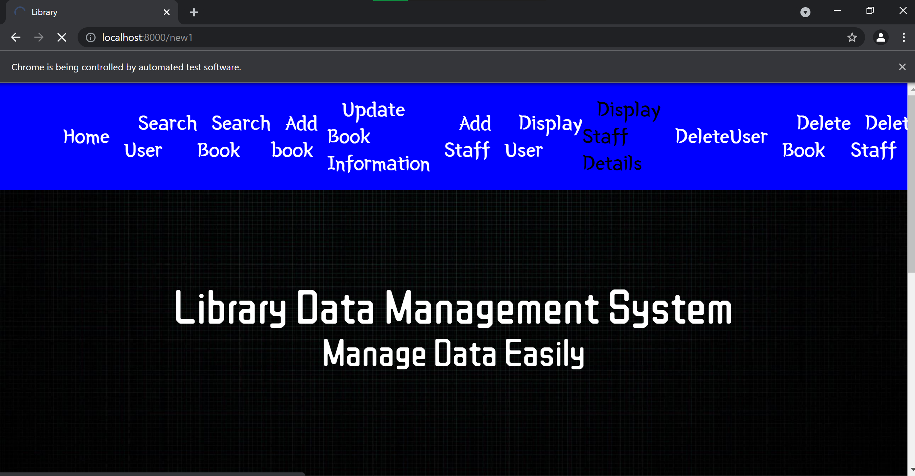

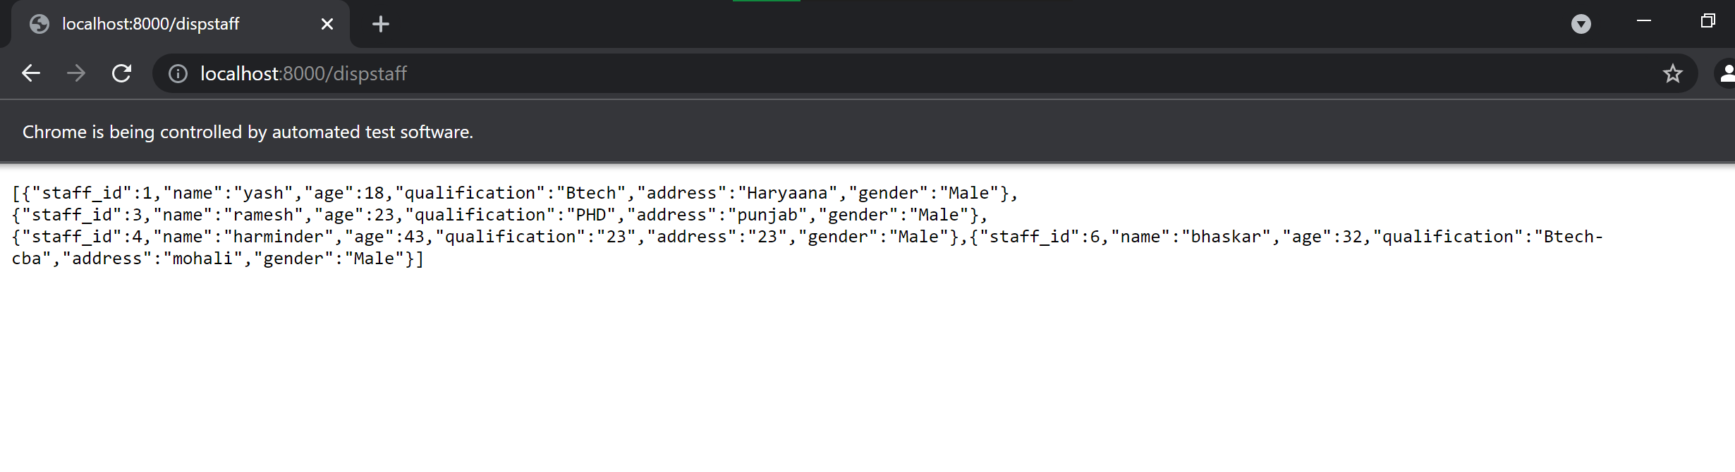

**6)Delete User Test**

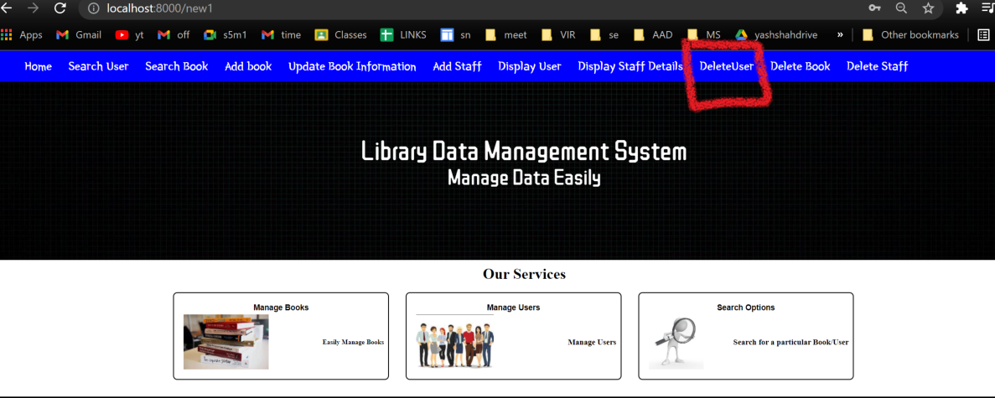

**Code:**

from selenium import webdriver

from selenium.webdriver.support.ui import WebDriverWait

from webdriver_manager.chrome import ChromeDriverManager

from selenium.webdriver.chrome.options import Options

import time

driver = webdriver.Chrome(ChromeDriverManager().install())

driver.get("http://localhost:8000/new1")

driver.maximize_window()

time.sleep(3)

searchbook=driver.find_element_by_xpath("//nav[@id='navbar']/ul//a[@href='/track']")

searchbook.click()

time.sleep(2)

a=driver.find_element_by_xpath("//body/form[@action='/track']//input[@name='user_id']")

a.send_keys("1")

time.sleep(1)

b=driver.find_element_by_xpath("//body/form[@action='/track']//button[@type='submit']")

b.click()

**OUTPUT**

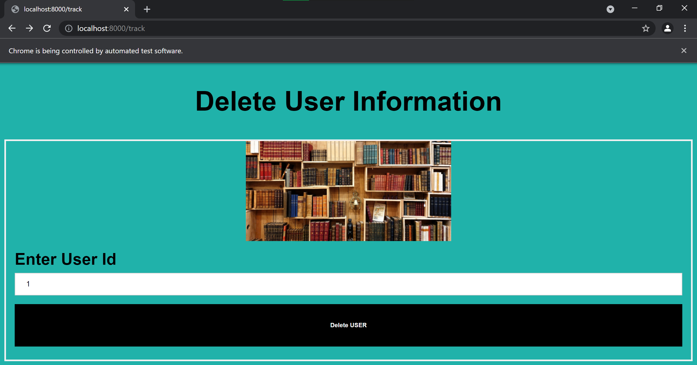

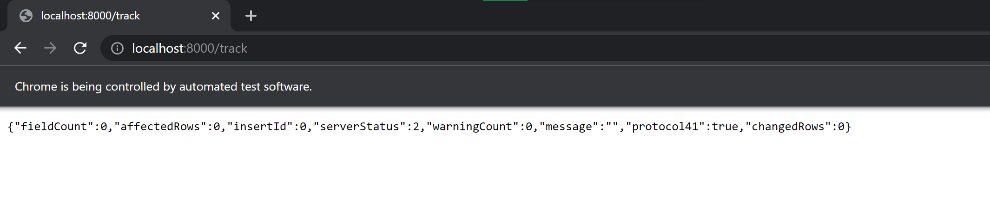

**Before Delete**

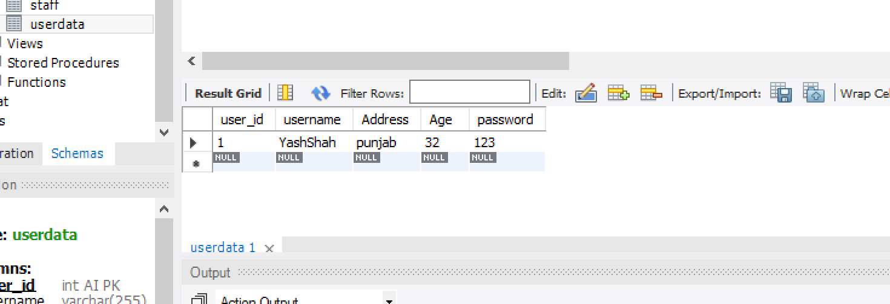

**After Delete**

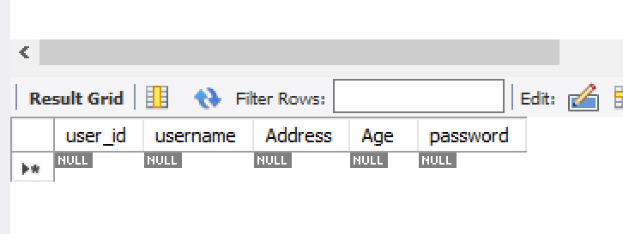

**7)Delete Book-TEST**

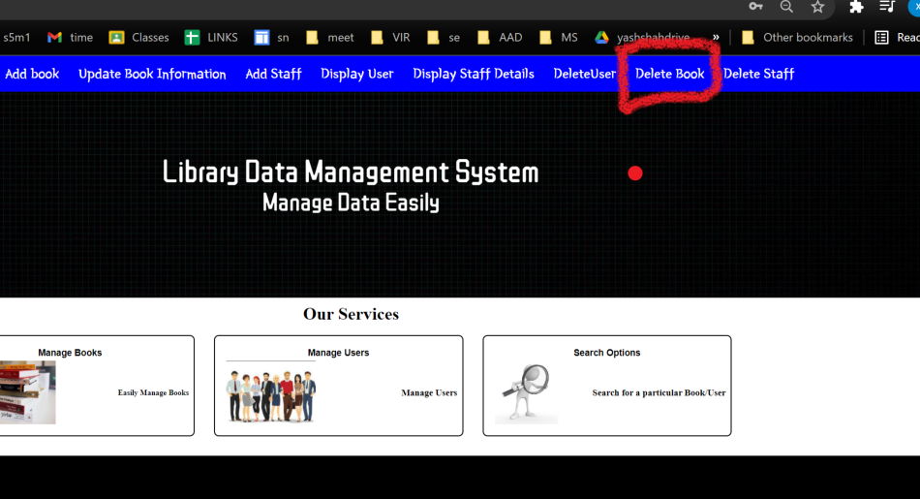

**CODE**

from selenium import webdriver

from selenium.webdriver.support.ui import WebDriverWait

from webdriver_manager.chrome import ChromeDriverManager

from selenium.webdriver.chrome.options import Options

import time

driver = webdriver.Chrome(ChromeDriverManager().install())

driver.get("http://localhost:8000/new1")

driver.maximize_window()

time.sleep(3)

searchbook=driver.find_element_by_xpath("//nav[@id='navbar']/ul//a[@href='/db']")

searchbook.click()

time.sleep(2)

a=driver.find_element_by_xpath("//body/form[@action='/track']//input[@name='book_id']")

a.send_keys("2")

time.sleep(1)

b=driver.find_element_by_xpath("//body/form[@action='/db']/div[@class='container']//h5[.='Delete Book Information']")

b.click()

**OUTPUT**

**Before Delete**

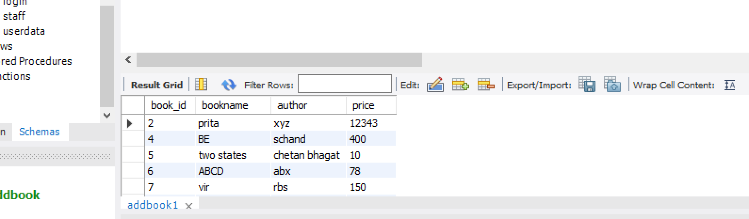

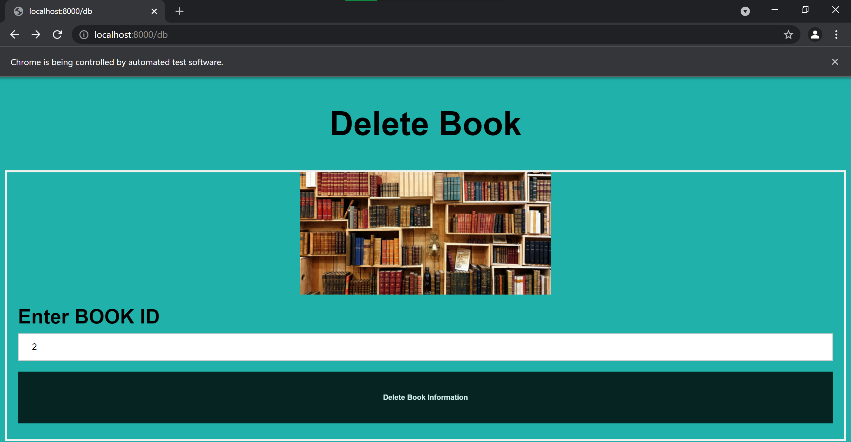

**After Delete**

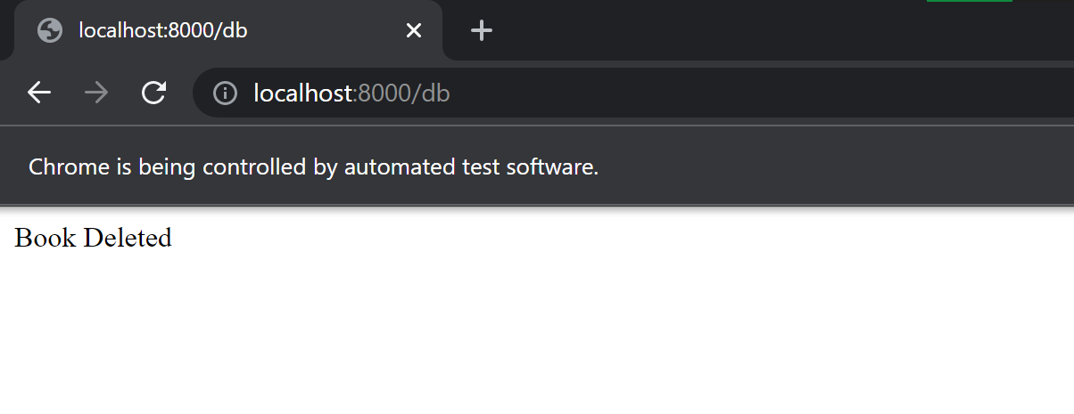

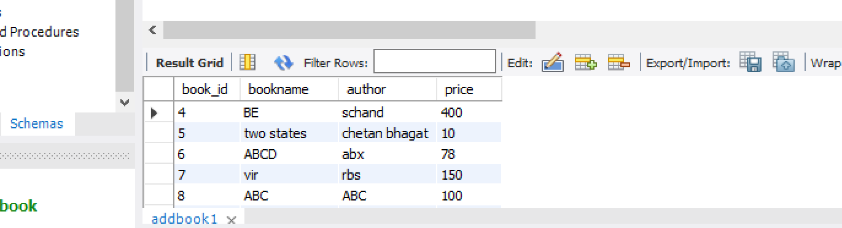

**8)Delete Staff-TEST**

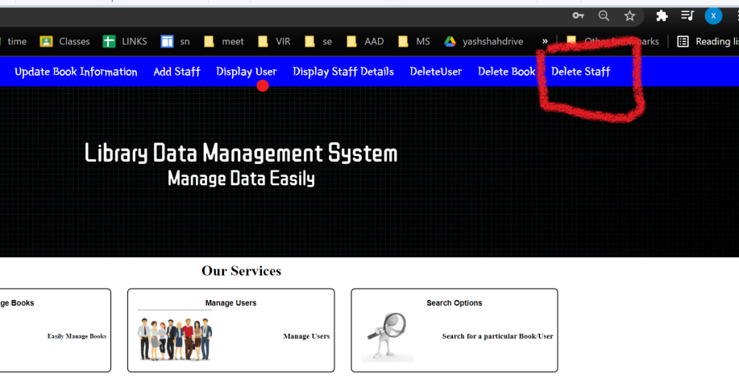

**CODE**

from selenium import webdriver

from selenium.webdriver.support.ui import WebDriverWait

from webdriver_manager.chrome import ChromeDriverManager

from selenium.webdriver.chrome.options import Options

import time

driver = webdriver.Chrome(ChromeDriverManager().install())

driver.get("http://localhost:8000/new1")

driver.maximize_window()

time.sleep(3)

searchbook=driver.find_element_by_xpath("//nav[@id='navbar']/ul//a[@href='/ds']")

searchbook.click()

time.sleep(2)

a=driver.find_element_by_xpath("//nav[@id='navbar']/ul//a[@href='/ds']")

a.send_keys("1")

time.sleep(1)

b=driver.find_element_by_xpath("//body/form[@action='/ds']//button[@type='submit']")

b.click()

**OUTPUT**

**Before Delete**

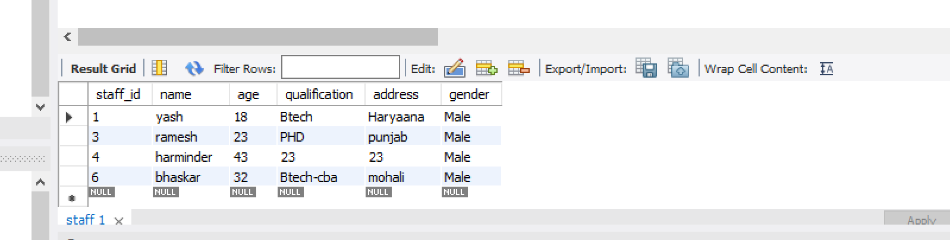

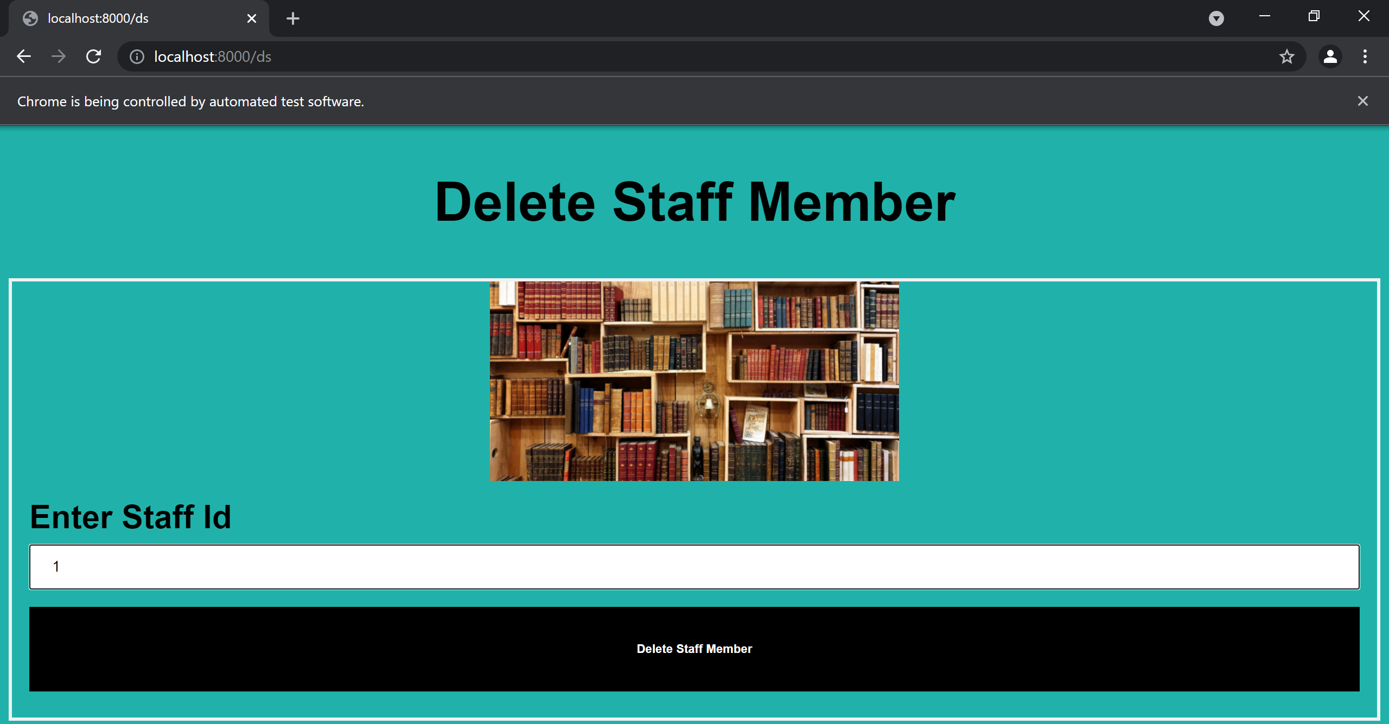

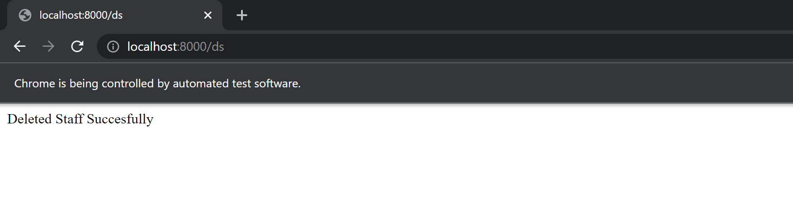

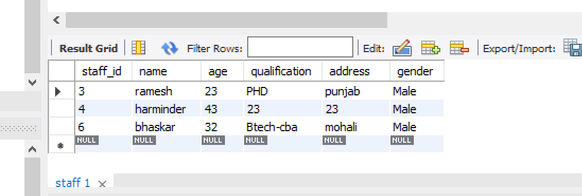

**9)Search Book Test**

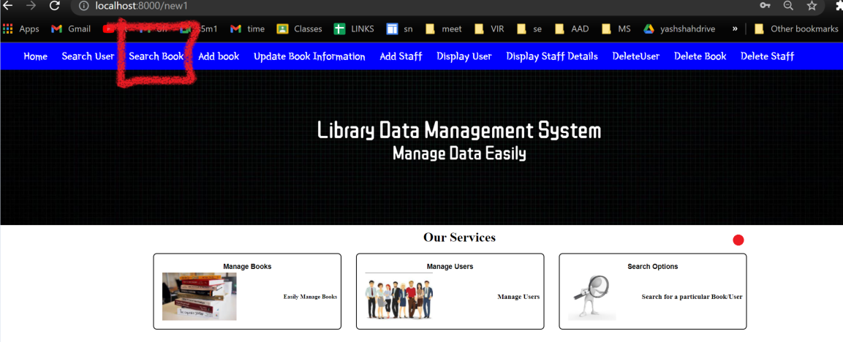

**CODE**

from selenium import webdriver

from selenium.webdriver.support.ui import WebDriverWait

from webdriver_manager.chrome import ChromeDriverManager

from selenium.webdriver.chrome.options import Options

import time

driver = webdriver.Chrome(ChromeDriverManager().install())

driver.get("http://localhost:8000/new1")

driver.maximize_window()

time.sleep(3)

searchbook=driver.find_element_by_xpath("//nav[@id='navbar']/ul//a[@href='/sb']")

searchbook.click()

time.sleep(2)

a=driver.find_element_by_name("book_id")

a.send_keys("4")

time.sleep(1)

b=driver.find_element_by_xpath("//body/form[@action='/sb']//button[@type='submit']")

b.click()

**OUTPUT**

